**INTEGRATED**

**TRANSACTION SYSTEM**

**USER MANUAL**

**LOGIN PAGE**

This is the first landing page:

**Admin Credentials**

Username = admin

User Password = admin

**Seller Credentials**

Username = keneth

User Password = 1111

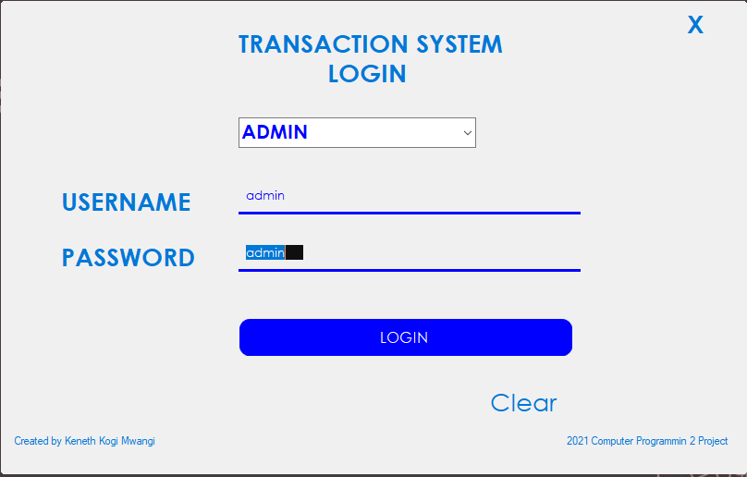

**ADD PRODUCTS PAGE**

Only accessible by the admin, to add products on stock to the system.

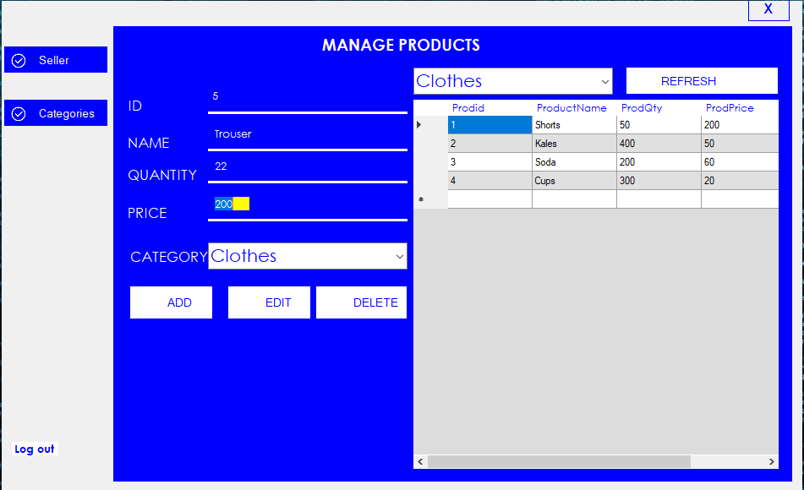

**CATEGORIES PAGE**

Adding different products Categories

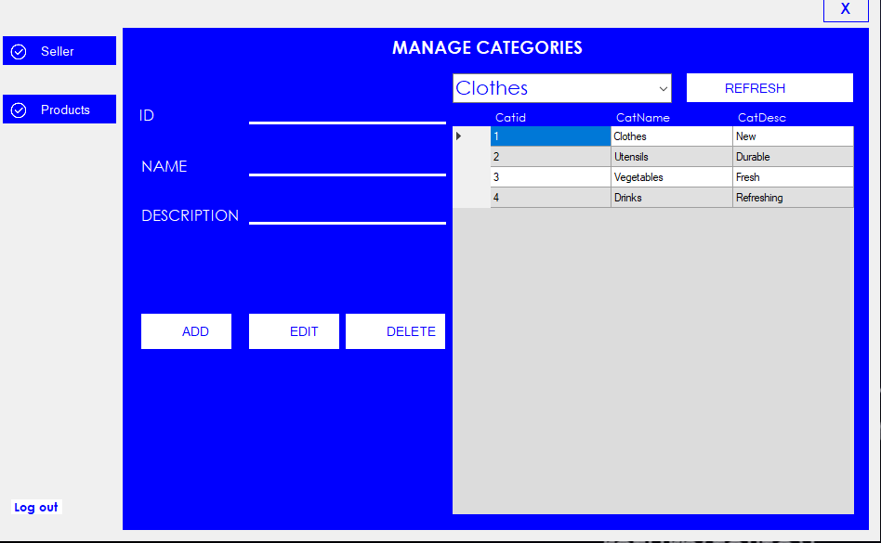

**SELLERS PAGE**

Adding different Sellers of the System

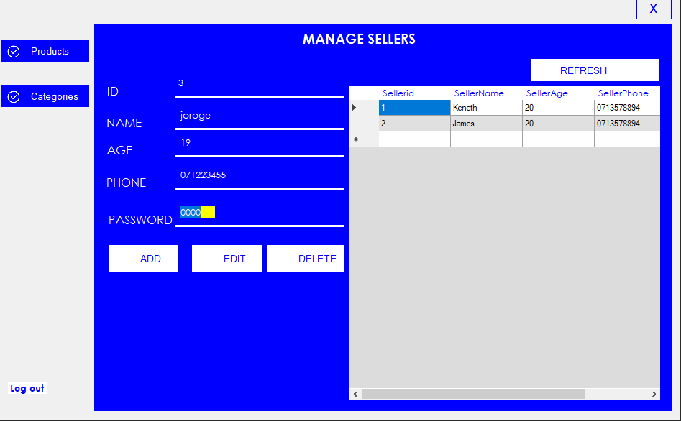

**POINT OF SALE**

Accessible by the sellers

